**06.09.2021**

**For Guidelines on Valuation, Empanelment of Valuers, Valuation formats etc., please refer to**

**Circular No.: CCO/CPPD-ADV/49/2019-20 Date: Wed – 3 Jul 2019**

**FORMAT OF VALUATION REPORT**

**To**

**The Chief Manager**

**SBI, RACPC,**

**Sector 5, Chandigarh VALUER REPORT UID NO.: CEV/RVO/299/0823/06082021**

**VALUATION REPORT (IN RESPECT OF LAND / SITE AND BUILDING)**

|  |  |  |  |  |  |  |  |  |
| --- | --- | --- | --- | --- | --- | --- | --- | --- |
| **I** | General | | | | |  |  | |
| 1. | Purpose for which the valuation is made | | | | |  | **To access the value of present asset** | |
| 2. | A | Date of Inspection | | | |  | 06.09.2021 | |
| B | Date on which the Valuation is made | | | |  | 06.09.2021 | |
| 3. | List of documents produced for perusal | | | | |  |  | |
|  | (i) Sales deed | | | | |  | No | |
| (ii)Layout plan | | | | |  | Yes | |
|  | (iii)Allotment Letter | | | | |  | NA | |
| 4. | Name of the owner(s) and his/their address (es) with Phone no. (details of share of each owner in case of joint ownership) | | | | | : | **Owner:** Smt. Asha Rani W/O Sh. Inter Raj | |
| 5 | Brief description of the property (including leasehold/freehold etc) | | | | | : | The property is built up on land area of 350 sqyd, consisting of G +1 floors.  Ground floor: 4 rooms, 1 drawring/dinning area, 2 kitchen, 4 toilets. First floor: 2 rooms and 2 toilet. | |
| 6 | Location of Property | | | | | : |  | |
| a) | | Plot No./Survey No. | | | : | - | |
| b) | | Door No. | | | : | - | |
| c) | | T.S. No./Village | | | : | Himshikha, Pinjore | |
| d) | | Ward/Taluka/Tehsil | | | : | Kalka | |
| e) | | Mandal/District | | | : | Panchkula | |
| 7. | Postal address of the property | | | | |  | Khewat Khatoni No. 49 Min/57 Min Khasra No. 49 share 7/504, i.e. 7 Biswa or 350 sqyd at Islam Nagar, Himshikha, Pinjore Hadbast No. 192, Tehsil Kalka, Distt. Panchkula (HR.) | |
| 8 | City/Town | | | | | : | City | |
| Residential Area | | | | | : | Yes | |
| Commercial Area | | | | | : | NA | |
| Industrial Area | | | | | : | NA | |
| 9 | Classification of the area | | | | |  |  | |
| i) | High/Middle/Poor | | | | : | Middle | |
| ii) | Urban/Semi Urban/Rural | | | | : | Semi Urban | |
| 10 | Coming under Corporation limit/Village Panchayat/ Municipality | | | | |  | Municipal Corporation Panchkula | |
| 11 | Whether covered under any State/ Central Govt. enactments (e.g. Urban Land Ceiling Act) or notified under agency area / Scheduled area / cantonment area. | | | | | : | NA | |
| 12 | In case it is an agricultural land, any conversion to house site plots is contemplated | | | | | : | NA | |
| 13 | Boundaries of the property | | | | | : |  | |
| North | | | | | : | Santoshi Mata Mandir | |
| South | | | | | : | Shop of Vinod Kumar | |
| East | | | | | : | Plot of Baldev | |
| West | | | | | : | Street | |
| 14.1 | Dimensions of the site | | | | | : | As per Approved map | Actuals |
|  | North | | | | | : | - | - |
|  | South | | | | | : | - | - |
|  | East | | | | | : | - | - |
|  | West | | | | | : | - | - |
| 14.2 | Latitude, Longitude and Coordinates of the site | | | | |  | **Lats. 300 46' 44.9'' N & Long. 760 55' 28'' E** | |
| 15 | Extent of the site | | | | | : | 350 sqyd | |
| 16 | Extent of the site considered for valuation (least of 14 A & 14 B) | | | | | : | **350 sqyd** | |
| 17 | Whether occupied by the owner / tenant? if occupied by tenant, since how long? Rent received per month. | | | | | : | Owner | |
| **II.** | **CHARACTERISTICS OF THE SITE** | | | | |  |  | |
| 1. | Classification of locality | | | | |  | Residential | |
| 2. | Development of surrounding areas | | | | |  | Developed | |
| 3. | Possibility of frequent flooding/sub-merging | | | | |  | Only in case of natural calamities | |
| 4. | Feasibility to the Civic amenities like school, hospitals, bus stop, market etc. | | | | |  | The basic facilities are available at a distance of about 2.0 km to 5.0 km | |
| 5. | Level of land with topographical conditions | | | | |  | Leveled | |
| 6. | Shape of land | | | | |  | Rectangular | |
| 7. | Type of use to which it can be put | | | | |  | Residential | |
| 8. | Any usage restriction | | | | |  | NA | |
| 9. | Is plot in town planning approved layout? | | | | |  | No | |
| 10. | Corner or intermittent House/flat/plot? | | | | |  | Intermittent House | |
| 11. | Road Facilities | | | | |  | Yes | |
| 12. | Type of road available at present | | | | |  | CC Road | |
| 13. | Width of road-is it below 20 ft. or more than 20 ft. | | | | |  | More than 20 ft. | |
| 14. | Is it a land-locked land? | | | | |  | No, There is free access to property | |
| 15. | Water Potentiality | | | | |  | Yes | |
| 16. | Underground sewerage system | | | | |  | Yes | |
| 17. | Is power supply available at the site? | | | | |  | Yes | |
| 18. | Advantage of the site | | | | |  |  | |
| 1. | | |  | |  | - | |
| 19. | Special remarks, if any, like threat of acquisition of land for public service purposes, road widening or applicability of CRZ provisions etc. (Distance from sea-coast/tidal level must be incorporated) | | | | | : | - | |
| **Part-A (Valuation of land)** | | | | | |  |  | |
| 1. | Size of Plot | | | | |  | - | |
| North & South | | | | |  | - | |
| East & West | | | | |  | - | |
| 2. | Total Extent of the plot | | | | |  | **350 sqyd** | |
| 3. | Prevailing market rate (Along with details/reference of at least two least deals/transactions with respect to adjacent properties in the areas) | | | | |  | Rs. 18000 per sqyd to Rs. 20000 per sqyd | |
| 4. | Guidelines Rate obtained from the Registrar’s office (an evidence thereof to be enclosed) | | | | |  | **Rs. 13000 per sqyd (Copy Attached)** | |
| 5. | Assessed/adopted Rate of valuation | | | | |  | **Rs. 19800/-per sqyd** | |
| 6. | Estimated value of land | | | | |  | 19800 x 350 = Rs. 6930000/- **Say Rs. 69.30 Lac** | |
| **Part-B (Valuation of Building)** | | | | | |  | **Ground floor and first floor** | |
| 1 | Technical details of the building | | | | |  |  | |
| a) | | Type of Building (Residential/ Commercial/ Industrial) | | |  | Residential | |
| b) | | Type of Construction (Load bearing / RCC /Steel Framed) | | |  | Load bearing | |
| c) | | Year of Construction  **Residual/Balance Economic life** | | |  | **2008, 47 years** | |
| d) | | Number of floors and height of each floor including basement. If any | | |  | No. floors 2, Height 10' | |
| e) | | Plinth area floor-wise | | |  | **GF+FF = 720** | |
| f) | | Condition of the building | | |  |  | |
|  | | | i) | | Exterior-Excellent, Good, Normal, Poor |  | Good | |
| ii) | | Inferior-Excellent, Good, Normal, Poor |  | Good | |
|  | g) | | Date of issue and validity of layout of approved map/ plan | | |  | NA | |
|  | h) | | Approved map / plan issuing authority | | |  | NA | |
|  | i) | | Whether genuineness or authenticity of approved map / plan is verified- | | |  | NA | |
|  | j) | | Any other comments by our empanelled valuers on authenticity of approved plan | | |  | **Although house is constructed but valuation of property is restricted to land only because there is approved building plan provied by owner of house** | |

**Specifications of constructions (floor-wise) in respect of Structure:**

|  |  |  |  |
| --- | --- | --- | --- |
| **Sr.No.** | **Description** | |  |
| 1. | Foundation | | Spread |
| 2. | Basement | | NA |
| 3. | Superstructure | | Brickwork in cement sand mortar |
| 4. | Joinery / Doors & Windows (Please furnish details about size of frames, shutters, glazing, fitting etc. and specify the species of timber) | | Marandi wood |
| 5. | RCC works | | Roof slab |
| 6. | Plastering | | Cement sand plaster |
| 7 | Flooring, Skirting, dadoing | | - |
| 8. | Special finish as marble, granite, wooden paneling, grills, etc. | | No |
| 9. | Roofing including weather proof course | | Yes |
| 10. | Drainage | | By concealed pipes |
| **Sr.No.** | **Description** | |
| 2. | Compound wall | | NA |
| Height | | As per drawing |
| Length | | As per drawing |
| Type of Construction | | Brick work in cement sand mortar |
| 3. | Electrical installation | | - |
| Type of wiring | | Concealed conduit |
| Class of fittings (superior / ordinary / poor) | | Ordinary |
| Fan points | | As per requirement |
| Spare plug points | | As per requirement |
| 4. | Plumbing installation | |
| a) | No. of water closets and their type | As per requirement |
| b) | No. of wash basins | As per requirement |
| c) | No. of urinals | As per requirement |
| d) | No. of bath tubs | As per requirement |
| e) | Water meter, taps, etc. | As per requirement |
| f) | Any other fixtures- sink | As per requirement |

**Details of valuation:**

|  |  |  |  |  |  |  |  |  |
| --- | --- | --- | --- | --- | --- | --- | --- | --- |
| **Sr.No.** | **Particulars of item** | **Covered area in sft.** | **Roof height in feet** | **Age of building in years** | **Estimated replacement rate of construction per sft.** | **Present Replacement cost Rs.** | **Depreciation** | **Net value after depreciation Rs. In lac** |
| 1. | GF+FF | 720 | 10' | 13 | **0** | 0 | 0 | **0/- Say Rs. 0** |

**Part C- (Extra Items) (Amount in Rs.)**

|  |  |  |  |
| --- | --- | --- | --- |
| 1. | Portico | : | Nil |
| 2. | Ornamental front door | : | Nil |
| 3. | Sit out/ Verandah with steel grills | : | Nil |
| 4. | Overhead water tank | : | Nil |
| 5. | Extra steel / collapsible gates | : | Nil |
|  | **Total** | : | **Nil** |

**Part D- (Amenities) (Amount in Rs.)**

|  |  |  |  |
| --- | --- | --- | --- |
| 1. | Wardrobes | : | Nil |
| 2. | Glazed tiles | : | Nil |
| 3. | Extra sinks & bath tubs | : | Nil |
| 4. | Marble/Ceramic tiles flooring | : | Nil |
| 5. | Interior decorations | : | Nil |
| 6. | Architectural elevation works | : | Nil |
| 7. | Paneling works | : | Nil |
| 8. | Aluminum works | : | Nil |
| 9. | Aluminum hand rails | : | Nil |
| 10 | False ceiling | : | Nil |
|  | **Total** | : | **Nil** |

**Part E- (Miscellaneous) (Amount in Rs.)**

|  |  |  |  |
| --- | --- | --- | --- |
| 1. | Separate toilet room | **:** | Nil |
| 2. | Separate lumber room | **:** | Nil |
| 3. | Separate water tank / sump | **:** | Nil |
| 4. | Trees, gardening | **:** | Nil |
|  | **Total** |  | **Nil** |

**Part F- (Services) (Amount in Rs.)**

|  |  |  |  |
| --- | --- | --- | --- |
| 1. | Water supply arrangements | **:** | Nil |
| 2. | Drainage arrangements | **:** | Nil |
| 3. | Compound wall | **:** | Nil |
| 4. | C.B. deposits, fittings etc. | **:** | Nil |
| 5. | Pavement | **:** | Nil |
|  | **Total** | **:** | **Nil** |

**Total abstract of the entire property**

|  |  |  |  |
| --- | --- | --- | --- |
| Part-A | Land | **:** | 69.3 lac |
| Part-B | Building | **:** | 0.00 |
| Part-C | Extra Items | **:** | Nil |
| Part-D | Amenities | **:** | Nil |
| Part-E | Miscellaneous | **:** | Nil |
| Part-F | Services | **:** | Nil |
|  | Total | **:** | **Rs. 69.30 Lac** |

**Note:**The Valuation has been made adopting market approach for the **cost of Plot** compared from similar properties situated in the same locality or in vicinity searched from web site of **housing.com**, **magicbricks.com, 99acres.com etc.** Average rate of 3 similar similar/ comparable available property considered as also verified personally from local real estate dealers& neighbors**.** There is huge gap in book value of the property as per Collector rates and fair market value prevailing as on date of the above property. Sale instances of prevailing market rates cannot be made available as people are always interested in saving the stamp duty and hence get the property registered at the Collector rates only which are much less than the market value.

This report doesn’t cover legal aspects, ownership aspects. Report is based on the documents & information as furnished by the bank. The verification of authenticity, genuineness of documents viz-a-viz matching the documents &records with those at site, location of property, encumbrances, ownership rights, lawful freehold fragmentation of house, its land use, Mortgage/Acquisition notices, if any, etc. etc. doesn’t fall under my purview/jurisdiction. The bank should confirm these aspects / seek legal opinion in these matters.

In case the valuation report submitted by the valuer is not in order, the Bank must bring the same to the notice of the valuer within 15 days of submission for rectification and resubmission. In case no such communication is sent, it shall be presumed that the valuation report has been accepted.

Also, such aspects as:

1. **Saleability**: Depends on demand, varying from time to time.
2. **Rental values**: Depends on demand & supply

1. Photograph of owner/representative with property in background enclosed

2. Screen shot of longitude/latitude and co-ordinates of property using GPS/Various Apps/Internet sites.

As a result of my appraisal and analysis, it is my considered opinion that the present The **Realizable** **value** of the above property in the prevailing conditions with aforesaid specifications is **Rs. 69.30 Lac** (Rs. Sixty-Nine Lac Thirty Thousand Only)

Place: Panchkula

Date: 06.09.2021

**Signature of Valuer**

**(Name Of The Valuer With Office Seal)**

The undersigned has inspected the property detailed in the Valuation Report dated­­­­­­­­­­­­­­­­­­­­­­­­­­­­ ________________on __________________. We are satisfied that the fair & reasonable market value of the property is Rs. _________________ (Rs.__________________________________________only)

Date:

**Signature**

**(Name of The Branch Manager with Office Seal)**

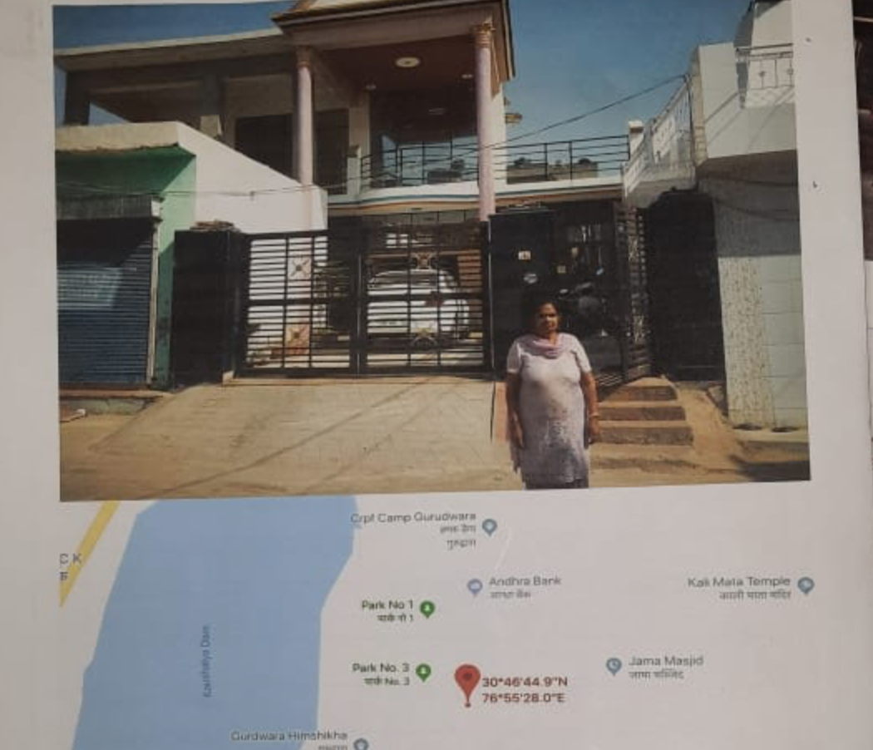

**COMPARATIVE ANALYSIS OF RATES FOR 350 sqyd RESI. PLOT IN Himshikha, Pinjore, Kalka, DISTT. Panchkula (HR.)**

1. Price of Resi. Plot as per 99acres.com= 2800000/100 =28000/- per sqyd

2. Price of Resi. Plot as per magicbricks.com = 320000/100 =32000/- per sqyd

3. Price of Resi. Plot as per housing.com=2800000/100 =28000 /- per sqyd

So Average rate of land per sqyd = (28000+32000+28000)/3 = Rs. 29333/- per sqyd

However, on inquiry with local property dealers working in the area, it was gathered that the residential plots are available in the range of Rs. 23000 to Rs. 24000/- per sqyd depending on the location, direction and front road width etc. The rate of plot such as under valuation should be Rs. 23500/- per sqyd according to its location.

**So, present market value of Property is assessed Rs. 23500/-per sqyd as on date and adopted for valuation**

**Signature of Valuer**

**Photos of Plot No. 6055, TDI City, Sec-92, Mohali, Distt. Mohali (Pb.)**

d

**Google Location**

**Signature of Valuer**

**Downloaded document**

**Signature of Valuer**